Hierarchical Model

📚 What is the Hierarchical Data Model?
# Source: AI Source: Provided by: [Data Path: Persons Table -> ID Column: 1, Name_En Column: Motasem Essam] -> From: [ChatGPT] on [6/10/2026]
The Hierarchical Model is one of the earliest data models used in databases. In this model, data is organized in a tree-like structure, where:
- Each record (called a node) has a single parent.
- Records may have multiple children.
- The structure forms a hierarchy — like a family tree or an organizational chart.

🌳 Basic Concept
# Source: AI Source: Provided by: [Data Path: Persons Table -> ID Column: 1, Name_En Column: Motasem Essam] -> From: [ChatGPT] on [6/10/2026]
- Parent → Child relationship
- One-to-many only
- Each child has exactly one parent, but a parent can have many children.
📌 Think of it like folders and files on your computer:
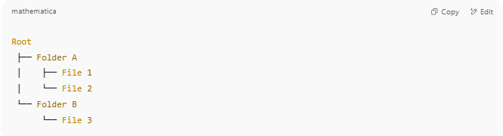
Root
├── Folder A
│ ├── File 1
│ └── File 2
└── Folder B
└── File 3

🧩 Key Features
# Source: AI Source: Provided by: [Data Path: Persons Table -> ID Column: 1, Name_En Column: Motasem Essam] -> From: [ChatGPT] on [6/10/2026]
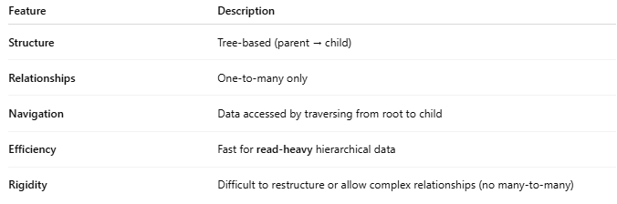
Feature | Description
Structure | Tree-based (parent → child)
Relationships | One-to-many only
Navigation | Data accessed by traversing from root to child
Efficiency | Fast for read-heavy hierarchical data
Rigidity | Difficult to restructure or allow complex relationships (no many-to-many)

📘 Example: Organization Hierarchy
# Source: AI Source: Provided by: [Data Path: Persons Table -> ID Column: 1, Name_En Column: Motasem Essam] -> From: [ChatGPT] on [6/10/2026]
Imagine a company:
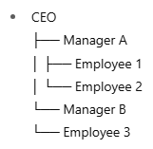
- CEO
├── Manager A
│ ├── Employee 1
│ └── Employee 2
└── Manager B
└── Employee 3
In database terms:
- CEO is the root
- Managers are children of CEO
- Employees are children of Managers

🧰 Real-Life Use Cases
# Source: AI Source: Provided by: [Data Path: Persons Table -> ID Column: 1, Name_En Column: Motasem Essam] -> From: [ChatGPT] on [6/10/2026]
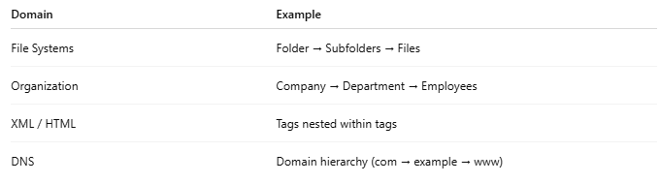
Domain | Example
File Systems | Folder → Subfolders → Files
Organization | Company → Department → Employees
XML / HTML | Tags nested within tags
DNS | Domain hierarchy (com → example → www)

🗂️ Example Record Format (OLD system like IBM IMS)
# Source: AI Source: Provided by: [Data Path: Persons Table -> ID Column: 1, Name_En Column: Motasem Essam] -> From: [ChatGPT] on [6/10/2026]
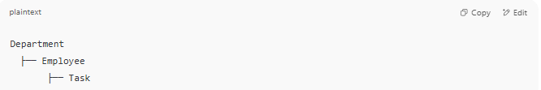
Department
├── Employee
├── Task

You’d have to retrieve data by following the chain: Department → Employee → Task.

🌳Visual Diagram: Hierarchical Model (Tree Structure)
# Source: AI Source: Provided by: [Data Path: Persons Table -> ID Column: 1, Name_En Column: Motasem Essam] -> From: [ChatGPT] on [6/10/2026]
Here’s a visual example of a Hierarchical Model representing a Company Organization:
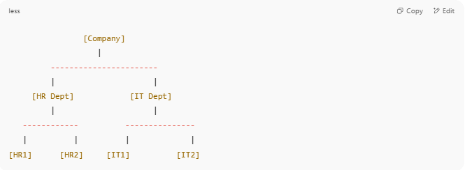
[Company]
|
-----------------------
| |
[HR Dept] [IT Dept]
| |
------------ ---------------
| | | |
[HR1] [HR2] [IT1] [IT2]

Breakdown:
- Company is the root node (top of the tree)
- Departments like HR and IT are child nodes
- Employees (e.g., HR1, IT2) are children of departments
- Each child has one parent (e.g., HR1 belongs only to HR Dept)

❌ Limitations
# Source: AI Source: Provided by: [Data Path: Persons Table -> ID Column: 1, Name_En Column: Motasem Essam] -> From: [ChatGPT] on [6/10/2026]
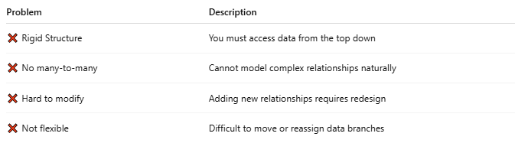]
Problem | Description
❌ Rigid Structure | You must access data from the top down
❌ No many-to-many | Cannot model complex relationships naturally
❌ Hard to modify | Adding new relationships requires redesign
❌ Not flexible | Difficult to move or reassign data branches

✅ Advantages
# Source: AI Source: Provided by: [Data Path: Persons Table -> ID Column: 1, Name_En Column: Motasem Essam] -> From: [ChatGPT] on [6/10/2026]
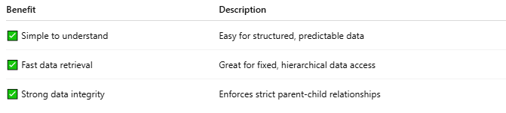
Benefit | Description
✅ Simple to understand | Easy for structured, predictable data
✅ Fast data retrieval | Great for fixed, hierarchical data access
✅ Strong data integrity | Enforces strict parent-child relationships

🔁 Comparison to Other Models
# Source: AI Source: Provided by: [Data Path: Persons Table -> ID Column: 1, Name_En Column: Motasem Essam] -> From: [ChatGPT] on [6/10/2026]
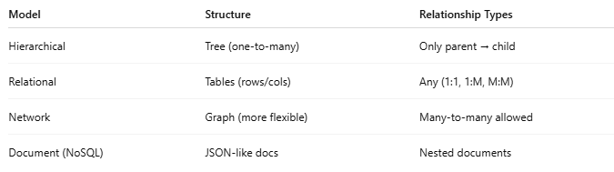
Model | Structure | Relationship Types
Hierarchical | Tree (one-to-many) | Only parent → child
Relational | Tables (rows/cols) | Any (1:1, 1:M, M:M)
Network | Graph (more flexible) | Many-to-many allowed
Document (NoSQL) | JSON-like docs | Nested documents

🔁 Comparison: Hierarchical vs Network vs Relational
# Source: AI Source: Provided by: [Data Path: Persons Table -> ID Column: 1, Name_En Column: Motasem Essam] -> From: [ChatGPT] on [6/10/2026]
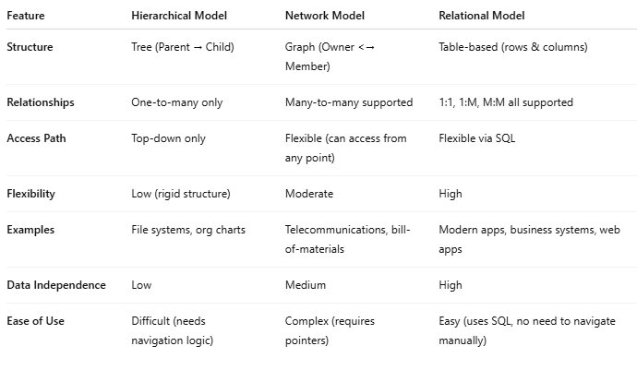

Feature | Hierarchical Model | Network Model | Relational Model
Structure | Tree (Parent → Child) | Graph (Owner <→ Member) | Table-based (rows & columns)
Relationships | One-to-many only | Many-to-many supported | 1:1, 1:M, M:M all supported
Access Path | Top-down only | Flexible (can access from any point) | Flexible via SQL
Flexibility | Low (rigid structure) | Moderate | High
Examples | File systems, org charts | Telecommunications, bill-of-materials | Modern apps, business systems, web apps
Data Independence | Low | Medium | High
Ease of Use | Difficult (needs navigation logic) | Complex (requires pointers) | Easy (uses SQL, no need to navigate manually)

🏁 Summary
# Source: AI Source: Provided by: [Data Path: Persons Table -> ID Column: 1, Name_En Column: Motasem Essam] -> From: [ChatGPT] on [6/10/2026]
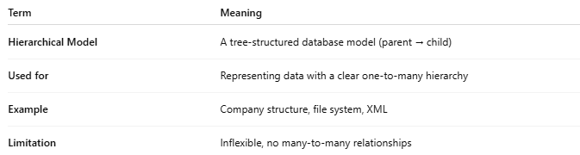
Term | Meaning
Hierarchical Model | A tree-structured database model (parent → child)
Used for | Representing data with a clear one-to-many hierarchy
Example | Company structure, file system, XML
Limitation | Inflexible, no many-to-many relationships

